SHALIBHADRA TRADERS

OUR SISTER CONCERN :
DHARMIN TRADERS , GAUTAM TRADERS

INTRODUCTION :
Delivering Only Excellence as a Leading Spices Supplier in India

Since our establishment in 1993, Shalibhadra Traders has been driven by the belief in honesty, quality, and long-term relationships. Guided by strong ethical business practices, we have earned trust as one of the most reliable names in the Indian spice industry.

Specializing in Cumin Seeds, Carom Seeds (Ajwain), and Mustard Seeds(Black small rai), we procure directly from farmers and process in our 30 TPD automatic Sortex & Cleaning plant, ensuring purity, consistency, and superior quality.

For us, quality is a commitment. We consistently meet and exceed customer expectations by delivering spices that embody freshness, authenticity, and value—always on time. Living up to our motto, “Quality with Quantity”, we maintain excellence across sourcing, processing, packaging, and supply.

At Shalibhadra Traders, we don’t just supply spices—we deliver trust and quality across India and beyond.

OUR EXPERTIES :

Our Expertise in Cumin Seed & Carom Seed (Ajwain) &Mustard seed (black rai)

At Shalibhadra Traders, we take pride in being one of the most trusted suppliers of Cumin Seed (Jeera) and Carom Seed (Ajwain) , Mustard seed (black rai) to spices manufacturer and other leading FMCG brands in India.

-ESTABLISHED IN 1993 , BACKED WITH 3 DECADES OF TRUST.
-DIRECT FARMER SOURCING + IN-HOUSE CLEANING & PROCESSING.
-SERVING FMCG COMPANIES , RETAIL CHAINS & INTERNATIONAL BUYERS
-FOCUSED ON QUALITY , RELIABILITY , AND LONG-TERM PARTNERSHIPS.

Cumin Seed (Jeera)
Trusted FMCG Supply: We are regularly supplying premium cumin seed to big players working in FMCG PROCURER , ensuring consistent quality and reliable service.

Direct Procurement: Our cumin seeds are procured directly from our nearest APMC Mandal, ensuring complete traceability.

Quality at Source: We closely monitor the growth of the plant, harvesting, and post-harvest handling under our direct supervision. This allows us to guarantee purity, natural aroma, and authenticity.

Firm Quality Commitment: Because we manage the process from sourcing to delivery, we confidently assure our customers of uncompromised quality.

Carom Seed (Ajwain)

Proven Track Record: we specialize in procuring, cleaning, and supplying CAROM SEED to FMCG companies and retail brands across India. Sourced directly from MANDAL APMC markets under our close supervision, our CAROM SEEDS are known for their sintense pungent taste & aroma , rich thymol content , medicinal & ayurvedic value & natural preservative quality..

Consistency & Trust: Our long-standing association with major FMCG players reflects our consistent quality, timely supply, and trustworthiness in the market.

Black Mustard Seed (Rai) –

At Shalibhadra Traders, we specialize in procuring, cleaning, and supplying Black Mustard Seeds (Rai) to FMCG companies and retail brands across India. Sourced directly from APMC KARJAN markets under our close supervision, our mustard seeds are known for their strong pungency, natural aroma, and high oil content.

We ensure that every lot is sortex-cleaned, lab-tested, and processed in our in-house facility (30 TPD capacity) before reaching FMCG Buyers in india

Our Expertise in Mustard Seeds (Rai)

Direct Farmer Linkage: Procurement from reliable sources ensures freshness and traceability.

Superior Cleaning: In-house sortex plant guarantees 99%+ purity.

Consistency: Long-term trusted supply to leading FMCG brands.

Quality Supervision: Monitoring from sourcing to dispatch ensures zero adulteration.

COMMODITY PORTFOLIO :

CUMMIN SEED (JEERA) : SINGAPORE 99

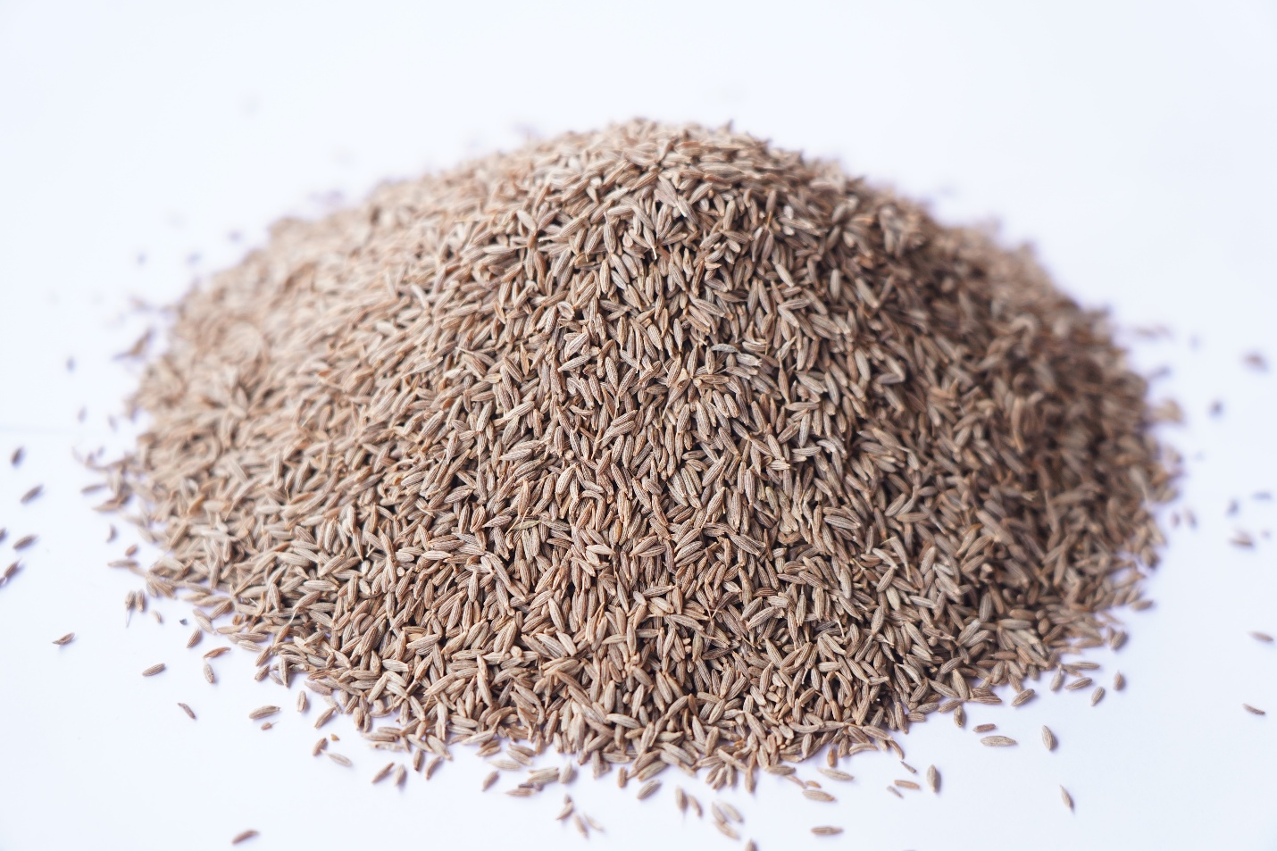

EUROPE 99.98% (EXTRA PREMIUM)
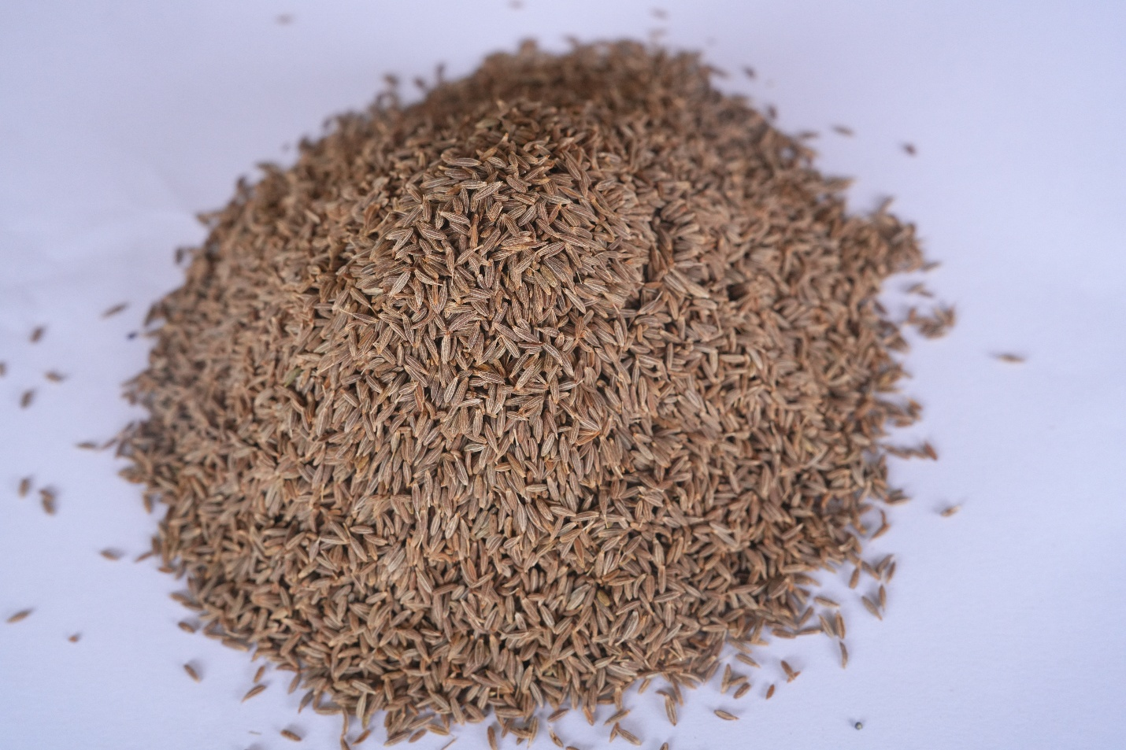

CARROM SEED : CARROM SEED GOLD (WHITE GREEN)

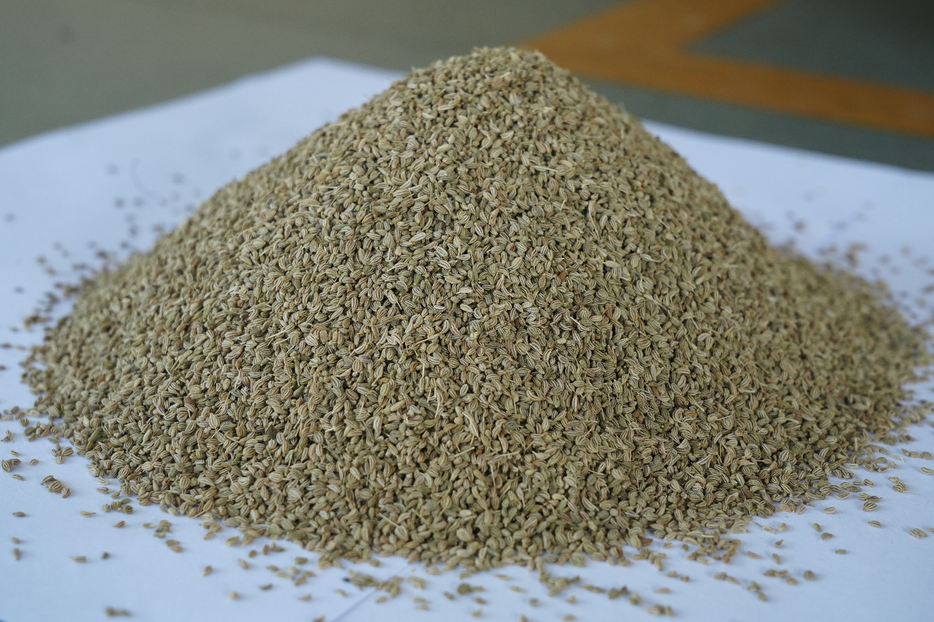

CARROM SEED PLATINUM ( PURE GREEN)

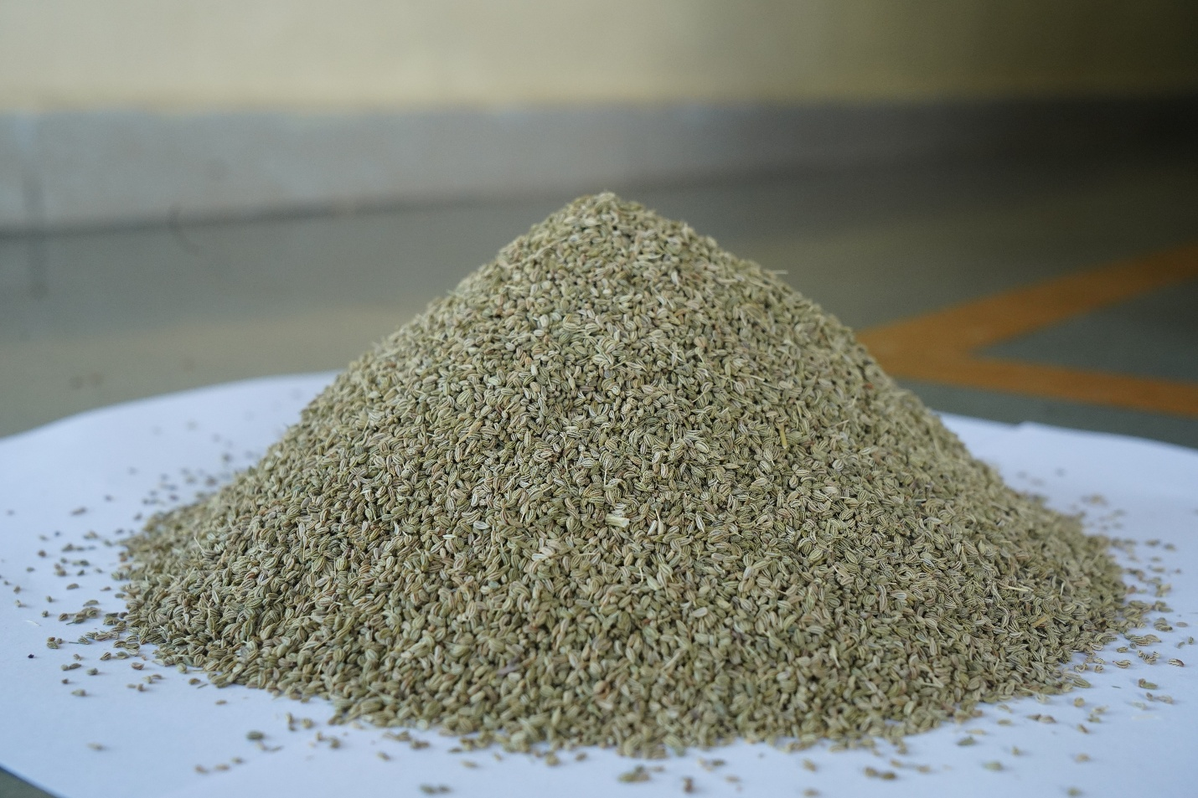

CARROM SEED PEARL (GREEN BOLD) (EXTRA PREMIUM)

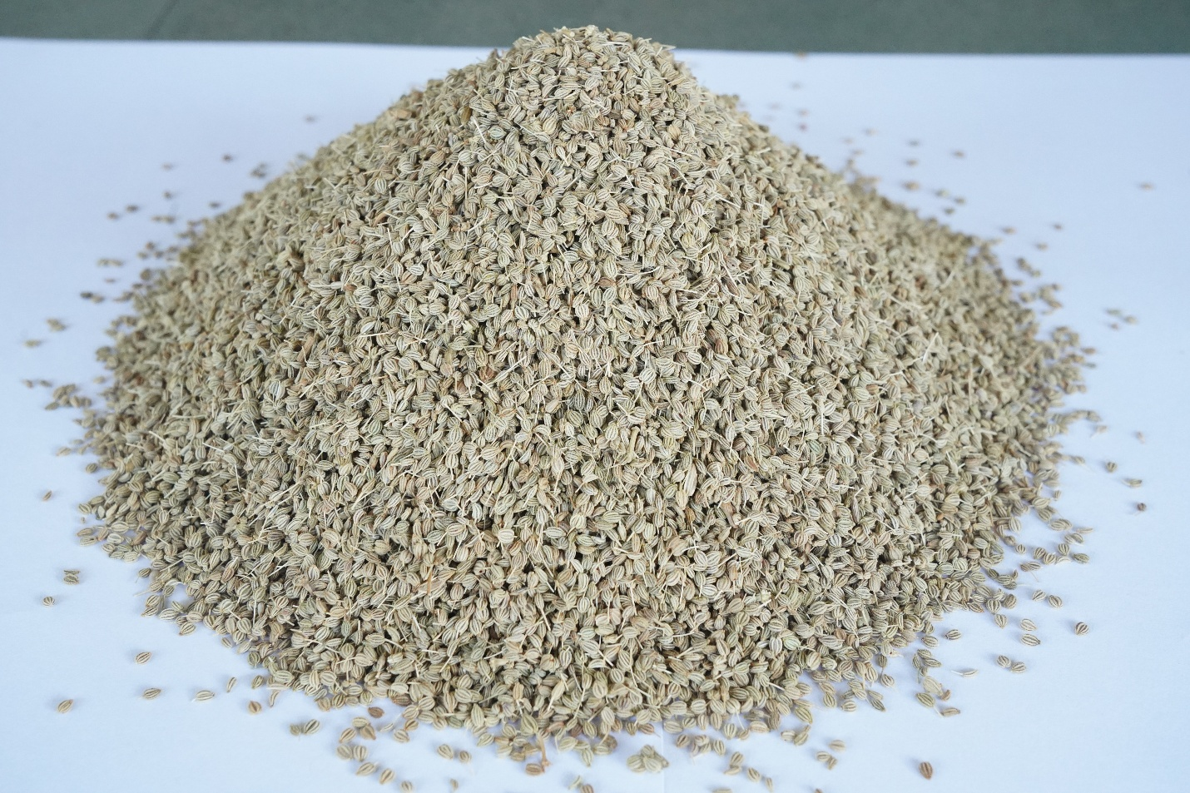

CARROM SEED SHALIBHADRA SPECIAL

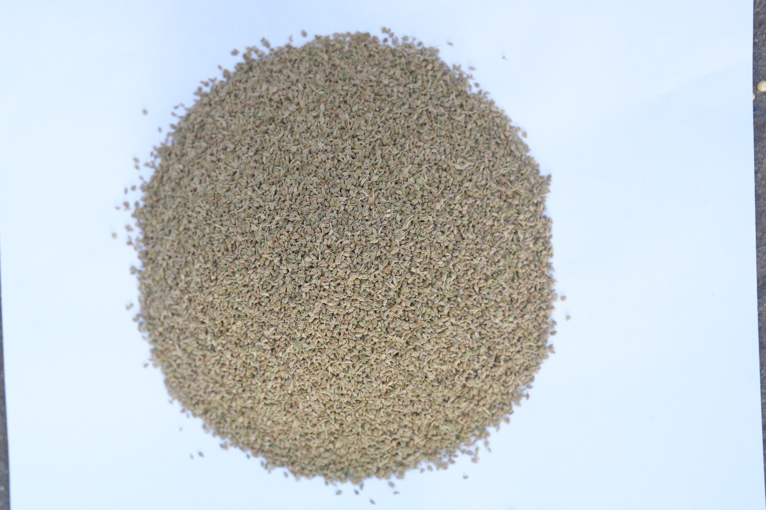``

MUSTARD SEED(BLACK RAI) : MICRO
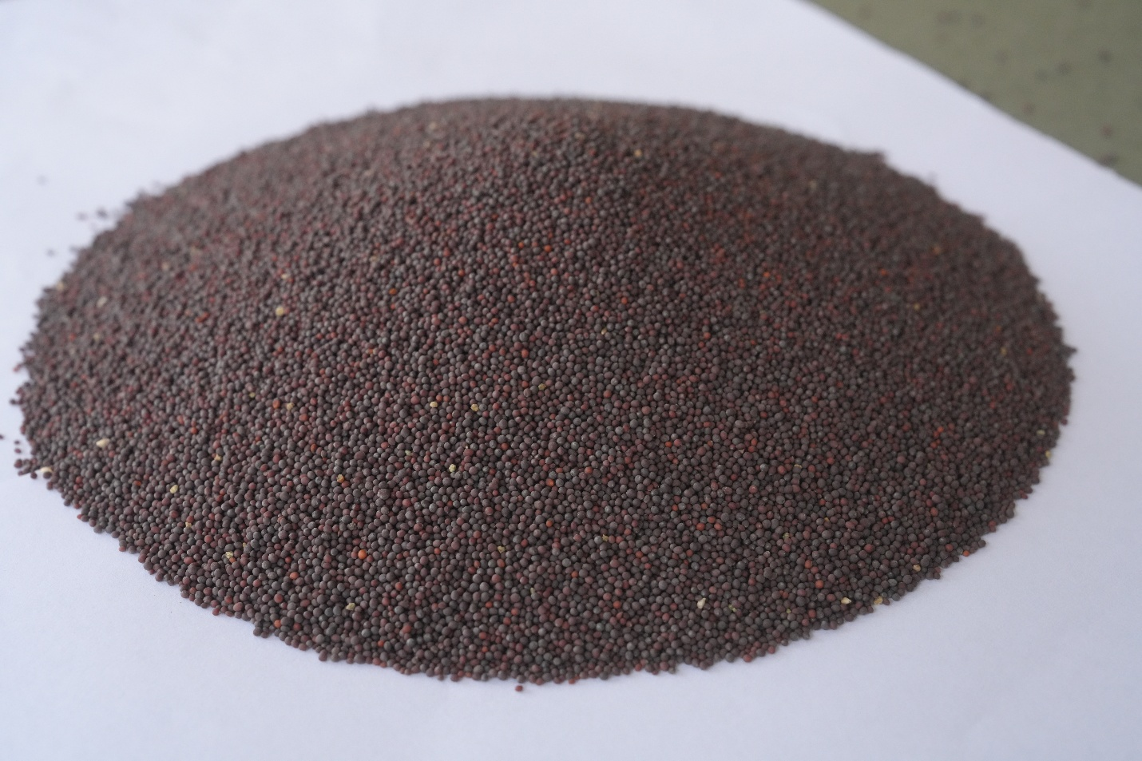

MEDIUM

BOLD

⚙ Infrastructure & Quality

30 TPD Automatic Plants for Sortex & Cleaning

Direct procurement from farmers to ensure authentic purity

Strict quality control for uniformity, aroma, and freshness

Trusted supplier to leading FMCG companies and retail players in India & abroad

🌱 Our Core Products

Cumin Seed (Jeera) – Rich aroma & flavor, premium export quality

Carom Seed (Ajwain) – Known for strong taste & medicinal value

Mustard Seed (Rai/Sarson) – Essential for food processing & seasoning

🌍 Why Choose Us?

30+ Years of Trust & Experience

Superior processing & packaging standards

Ability to handle bulk orders with consistency

Competitive pricing with timely delivery

🤝 Let’s Collaborate

After analyzing your product profile, we believe our processed and Sortex-cleaned Mustard Seed, Cumin Seed, and Carom Seed can add value to your business. We invite you to connect with us and explore long-term collaboration.

📧 shalibhadratraders1660@gmail.com
📞 +91 94083 48629

